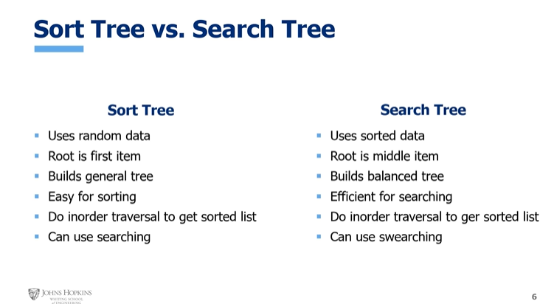

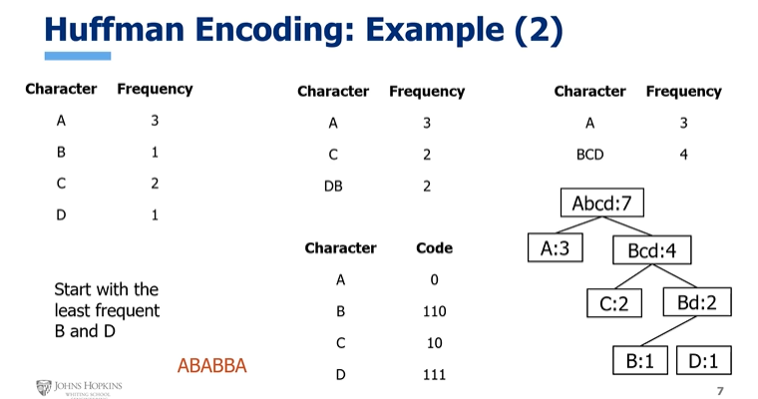

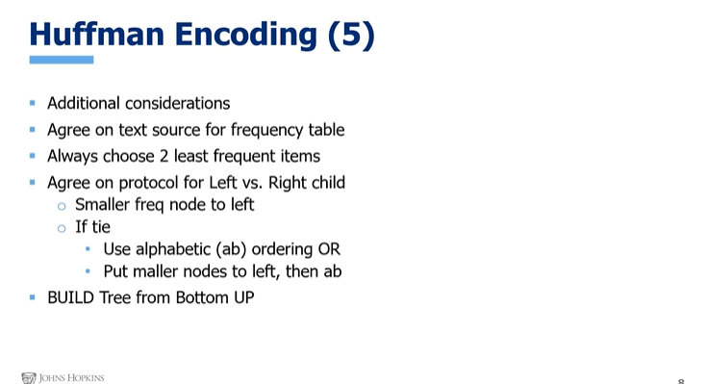

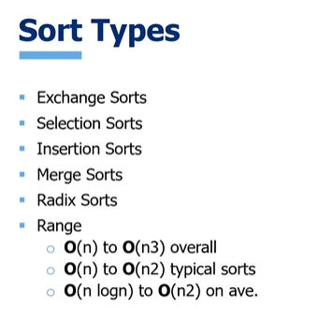: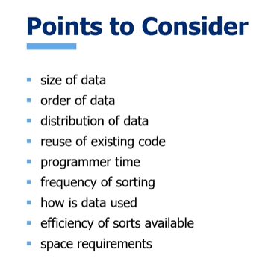

Distribution is likelihood of being accessed

For following chart fill in Big O AND type of data in each box.

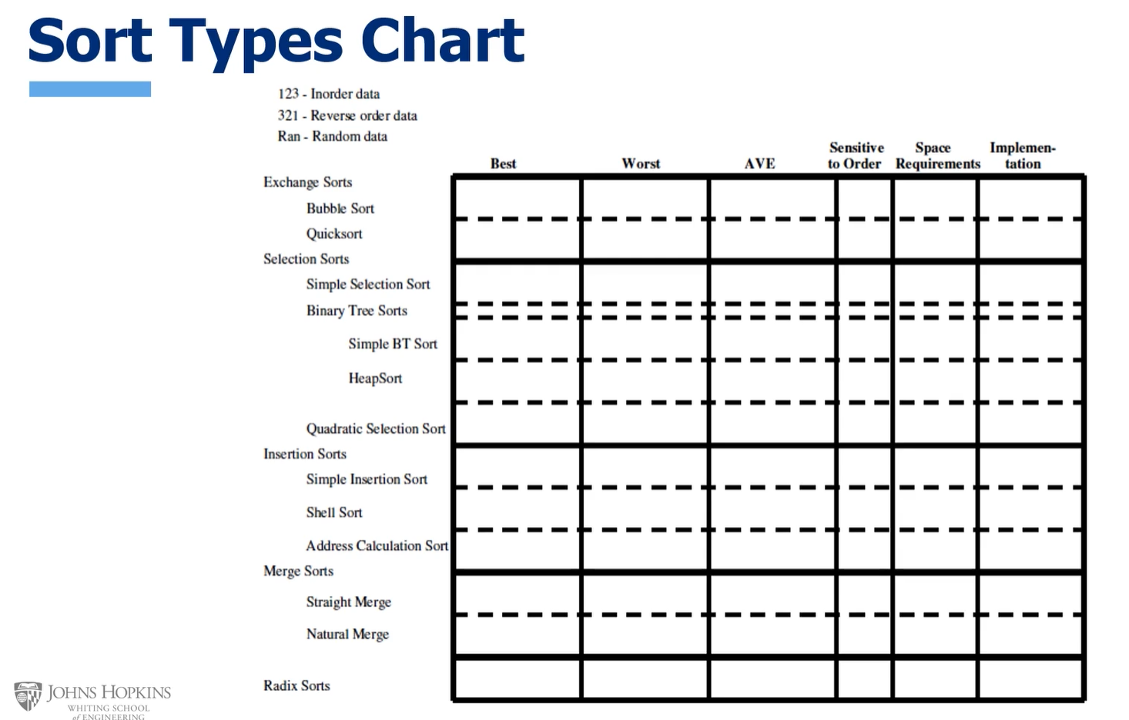

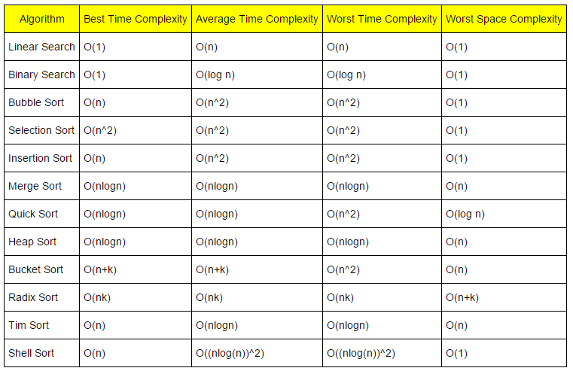

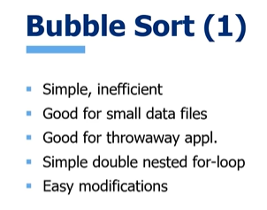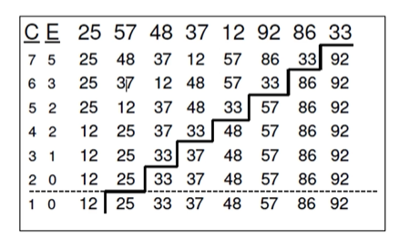

Pairwise comparisons. Over and over until they reach final position. Comparisons and then exchanges until 0

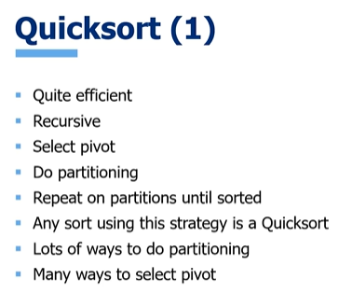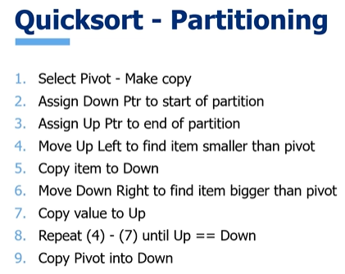(one way)

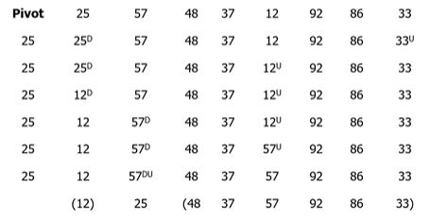 follow above algorithm until you have two partitions

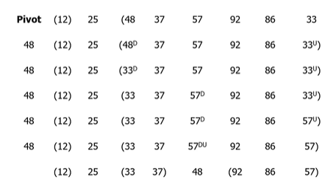do again on remaining partition, do again, until sorted

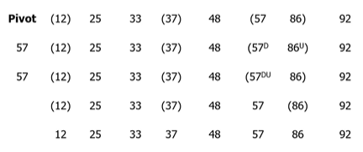26 comparisons, 8 exchanges in this ex

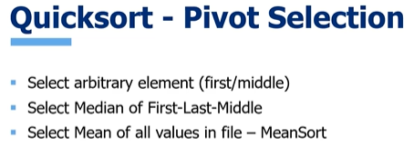arbitrary is sometimes even/uneven partitions result

Median results that you never have largest or smallest – never an empty partition, so not O(n^2) possible anymore

Cost of calc mean is O(N), but mean is not usually an element in the file (external pivot)

Quicksort is O(N lg N) overall.